Games Programming II
Coursework Document
Computer Games – Software Development
Andrea Caramia
S1718189

I confirm that the code contained in this file (other than that provided or authorised) is all my own work and has not been submitted elsewhere in fulfilment of this or any other award.
Signature.

Table of Contents

Display: _______________________________________3
Camera: _______________________________________3
Audio: ________________________________________4
Time: _________________________________________5
Player: ________________________________________6
Model: ________________________________________8
Shader: _______________________________________11
Game Object: __________________________________15
Game: ________________________________________19

Code Explanation
Foreword
This chapter’s purpose is to walk the reader through the various classes and files present in the project. The order in which they are presented does not necessarily follow the order in which they have been implemented; rather, it starts with simple, stand-alone concepts and gradually moves on to the more abstract elements that result from the aggregation of the basic building blocks.
Important bits of code, especially methods that are entirely made from scratch, will be discussed in greater detail than code that was implemented partially or entirely from the laboratory material.
The “Game” class, which is where almost every calculation takes place, will be described last, after every element has already been presented.
I – Display
This class is featured first as it required almost no tweaking in respect to the one supplied in the laboratory material. Its purpose is to provide window creation using the GLEW wrapper, it handles the general GL Context, buffer manipulation and a clearDisplay() method to clean the screen at the start of each new frame.
The most relevant method in the class is its initialise() function, where SDL_Init is called, which handles all the start-up procedures, such as setting bit-depth for colours, enabling z-buffering, double buffering and backface culling.
II – Camera
Like many core elements of this project, a Camera class was initially supplied via laboratory material, however it has undergone several changes to accommodate to the project’s requirements.
Here follows a quick overview of what this class aims to accomplish.
The Camera’s role is to determine what space is to be drawn on screen, establishing a list of restriction such as field of view, minimum and maximum object distance and perspective.
Its post-construction initialiser method has the following signature
void initialiseCamera(const vec3& pos, float fov, float aspect, float nearClip, float farClip);
The aspect is passed in the form of screen width over screen height, while every other value is mostly down to preference. These four values are used to calculate the projection value, which is a 4x4 matrix that can be obtained calling the perspective() method from the glm namespace.
Said value is then used in the getViewProjection() method – along with private vector3s such as up, forward and right – to calculate the Model View Projection in the shader class.
It will be mentioned again later, but it is important to highlight how this is crucial to get a model to be rendered according to its size and position in relation to the player.
On top of this, the class also provides pitch/yaw methods, which allow the player to rotate the view, and position setting methods such as setPosition() for hardcoded transform manipulation or translate() for movement in relation to the previous position. All these methods have been inlined in the .h file, as their small instruction set and frequency call order should make them suitable for the inlining process. Inlining a function is a useful practice for these methods as the compiler generates less overhead, creating a smaller executable, which results in shorter execution time.
III - Audio and Audio Manager
An Audio class was already supplemented in the practical sessions, so here follows a quick rundown of what it consists of.
Audio is responsible for finding the computer’s audio device and create an Open Audio Library context that is tied to it.
Via personal experimentation, I found out that, much like OpenGL, there can only be one AL context, which makes having more than one active Audio class instances rather cumbersome, as subsequent contexts (which are created in the class’ constructor) would fail to be generated, rendering the class useless. A first approach to solve the problem included an attempt at turning the class into a singleton object, for ease of access. Ultimately, it was abstracted inside a manager file – more on which later.
In terms of functionality, the class makes it possible to search for a .wav file in the resource folder and converts it into a playable clip, which is stored as an unsigned integer. An interesting detail that I noticed during development is that the loadSound() method only works with 44.1KHz frequencies files. Many sounds that were imported into the project from the internet were not complaint with that requirement, so they were re-saved with the Audacity audio editor into a Microsoft signed 16-bit file, which ensured the required 1411 Kbps bitrate.
Lastly, it also provides data for playing, pausing and stopping audio playback. Lastly, it allows the developer to set a listener, which makes it possible to determine how far a sound is in relation to the player’s ears.
Audio Manager on the other hand is entirely contained within its header file and it works as follows; it has a global static instance of Audio, so that every class that imports AudioManager.h can access the same AL context. The class provides a handle to the loadSound() method, and it adds a playAudioNoRepeat() method, which checks that, when a new clip is to be played, it is not being played already so that it does not play the same sound each frame (for background music) or on multiple subsequent instances (when instantiating multiple objects).

IV - Time
Time.h is a simple header file that provides necessary time-based data that is globally available.
It provides an updateDeltaTime() method that returns a double precision float value, which in essence, is retrieved via measuring the last time deltaTime was calculated with the current one.
The tools that make this possible are found in the “chrono” namespace, a subsection of the standard C++ library, which enables us to retrieve the CPU ticks. The way time is calculated can also be scaled.
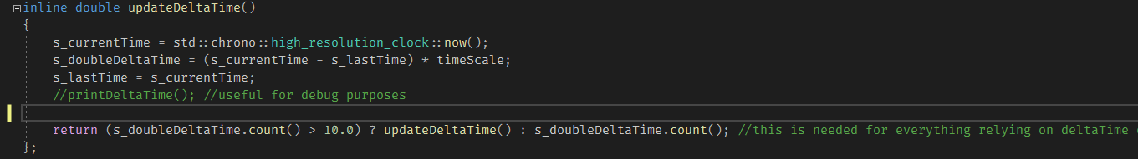
1 Method that returns the time between the current and last frame
Delta time is used in games to make sure that sensible values like positions and rotations are updated correctly, regardless of computer’s frame rate. This means that a machine that has more computational power would not make a character go faster than that of a machine that performs worse, as their respective deltas would make sure that any values influenced by it would be the same at any given time. For reference, if a machine A has a framerate that is exactly double the amount of a machine B, A’s delta would always be half as big as B’s, evening the result.

V – Player
The Player class provides a series of useful methods as far as the user is concerned; it implements a camera instance (the only one available in the scene) and has access to Audio Manager.
It does not provide movement methods, as those are handled externally, however it does implement a new concept, providing a jump() method that makes use of it. The relevance of this method stems from it being the first form of physics that was implemented in the project;
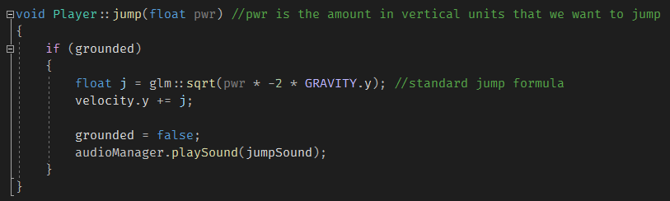
2 Jump function
Jumping is implemented via standard physics: the only parameter – a “jump power” value – is multiplied by two times negative gravity, and the result is then subjected to a square root operation.
The class also uses an internal “grounded” boolean to determine if jumping is possible in the current frame, and to perform gravity checks, as follows.
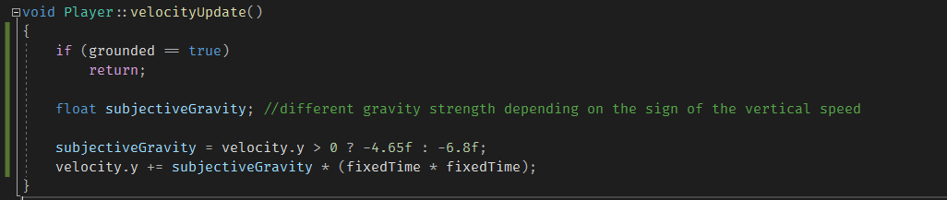
3 Internal velocity updating function
Following another rule of game development, the velocityUpdate() private method updates the velocity vector3, adding to it the result obtained by multiplying the current gravity strength by the square of “fixedTime”. The fixed timestep variable is used in game engines to perform physics-related checks, which need to happen at a consistent pace that is not tied to the framerate, making deltaTime not the optimal choice.
The value chosen for the timestep is 0.2, as it is set in the Unity engine.
Lastly, this class’ equivalent of the method, which is called every frame in the main loop, is called updatePlayer(). On top of calling velocityUpdate(), it is responsible for translating the camera by the newly refreshed velocity value, and then performs two important checks.
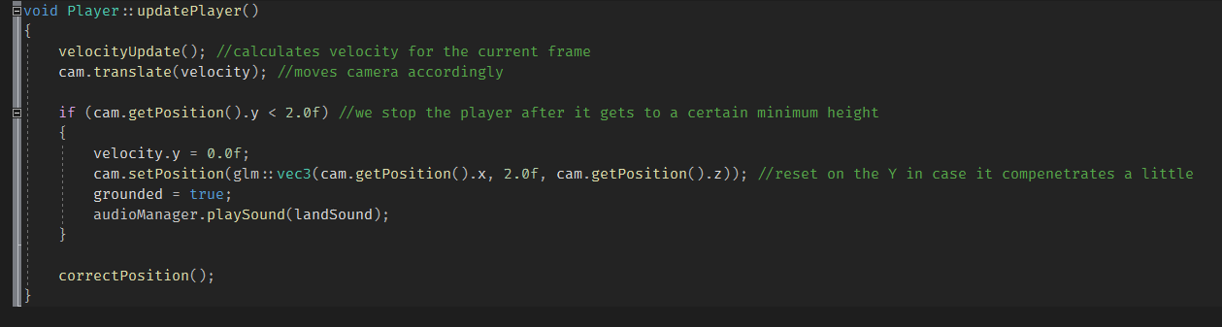
4 updatePlayer() method
The player’s height is checked, and if it is below a certain threshold, its vertical speed is set to zero, the camera gets corrected to the mentioned threshold and the “grounded” boolean is set to true.
Then, it makes sure the player is in the correct area above the map, making it impossible to walk off the map.
This class does not make use of the collider class, not it performs any sort of collision check; such concepts, however, are present in other classes.

VI – Model, Introduction
Model.h is header that contains a series of different related classes, such as Mesh and Texture, which are used to read and draw a 3D model (.obj), which can also be textured. On top of this, all collision-related classes, which are Collider and its two derived classes, are also kept here.
As such, two different .cpp files define the concepts that are declared here.
Model.cpp was mostly provided during the practical sessions; the classes it implements – Mesh and Texture – handle a great deal of calculations that are needed to load a 3D object onto memory.
VI.a - Model, Meshes
The methods that handle the model loading procedures are:
void Mesh::loadModel(const std::string& filename)
Mesh::initWithModel(const IndexedModel& model)
The former method is public, and it is only called from the main game class. The latter method takes in an “indexed model” type object, which is created and passed by loadModel.
The way this method operates is quite complex; it is important to specify that in order to get an .obj in our scene it needs to be loaded onto memory, which happens in the following way; we use a drawCount private unsigned integer that keeps track of how many indices the object has. This happens whenever the class loads a new model.
Then, it generates a Vertex Array Object (VAO), which is a special type of object that holds references for every 3D object related element, such as the Vertex Buffer Objects (VBOs), the Index Buffer Objects (IBOs) and the layout specification of the vertices.
Then, it proceeds to add all the aforementioned buffers to the VAO; it uses a special GL function named glVertexAttribPointer to inform the VAO about the layout of each set of vertices that is added. Although it was provided already in a fully functioning state in the labs, it is worth to add some details about how this method works: needs the following arguments:
- Index – the vertex in the array that serves as the starting point
- Size – how many components there are in a single vertex
- Type – the data type
- Normalised – boolean where true means the values will be clamped between 0 and 1
- Stride – the offset (in bytes) between one vertex and the next
- Pointer – an offset from the first component specified in the array
The operation of binding a buffer to the VBO, putting model data into it, then specifying the vertex attributes is performed three times; once for the vertex positions, once for the texture coordinates, and once for the normals. Lastly, the IBO is loaded onto the VAO, which is then unbound after all the information has been loaded on GPU memory.
Lastly, since every relevant information was added onto the VAO, it makes it easy to draw the mesh from an external class via the public draw() method, which simply binds the model’s VAO and calls glDrawElements().

VI.b – Model, Textures
Model.cpp also contains the textures implementation methods, the most important of which is the constructor method; its only parameter is a string that contains the file path to the texture we want to load in memory.
In order to do so, the method makes use of functionalities provided in the stb_image.h file, which extracts data in the form of a C-string. The data is then loaded onto the bound textureHandler.
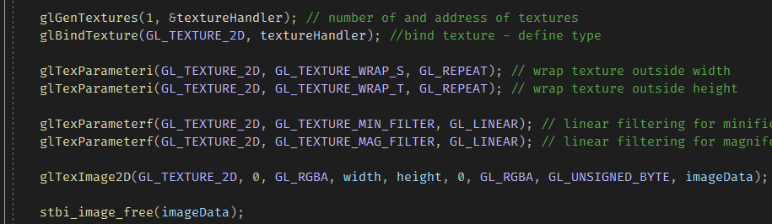
5 Texture Constructor
When the mesh is to be drawn, the public void method Bind() sets the model’s texture as active and binds it. This method is incorporated in the GameObject class, which will be presented shortly.
VI.c – Collisions
Some core concepts of colliders were provided in the practical sessions; however, it was limited to sphere-shaped colliders with minimal collision detection methods.
This class expands this feature by creating a virtual base class named Collider, which the SphereCollider and BoxCollider inherit from, while the new collision procedures will be discussed in a later chapter.
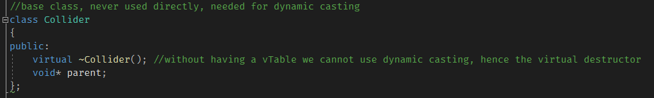
6 Collider base class, the destructor is set as virtual so that the compiler generates a v-Table for the class.
The parent pointer member is used so that we can externally tell the collider which Game Object it belongs to, faking a component system.
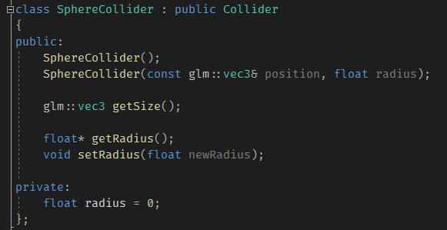
7 Sphere collider class overviews, inherits from collider – public access modifier makes the parent member accessible.

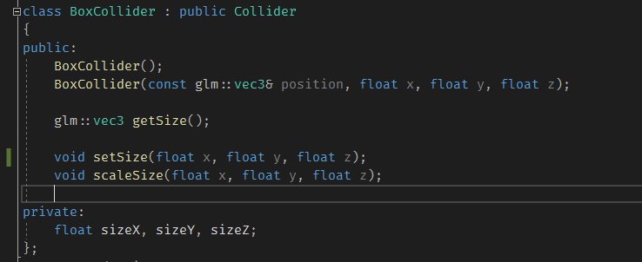
8 BoxCollider class overview
The two derived classes offer core functionalities like returning their size, scaling or hard setting the size. They are accessed from the Game Object they belong to in the physics-loop part of the Game class. They do not hold a position value as that I retrieved from the transform component.

VII – Shader
The last class that was provided in the labs is the Shader class, which handles loading, parsing and binding shader scripts to the GPU. The only amendment that was done directly to this class is related to filling uniform data, as this projects’ shaders use a variety of external data.
Here is a quick overview of the methods contained in the class, while the rest of the chapter is going to be dedicated to the shader files themselves.
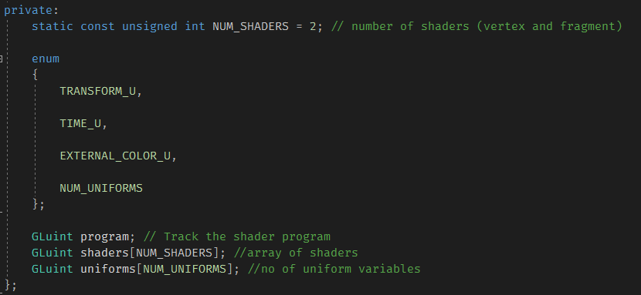
9 Shader class private members overview
Starting from the private members, we can see the class makes use of an enumerator type for the uniforms to ensure that it is possible to keep the code readable, as every member of the uniforms array will now be referenced with its own name.
The program member is an aggregate of all the individual shader programs after being linked together, while the shader array contains all the shader types – which in this case are only vertex and fragment, but it could be expanded to, for instance, also manage Tessellation Control and Evaluation shaders.
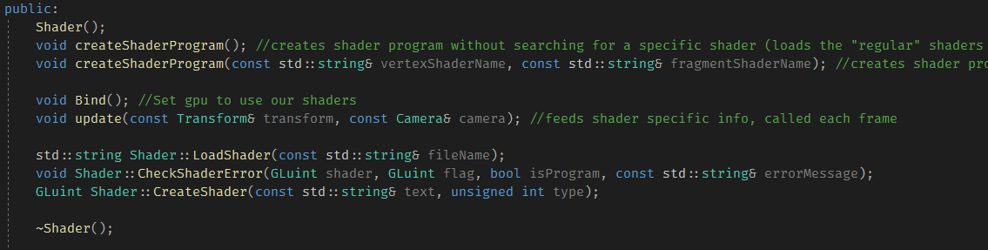
10 Shader class public members overview
Every member of figure 10 was already provided. LoadShader(), CheckShaderError(), and CreateShader() are the three methods used to read a shader from its file path, see if it is written correctly (the compiler offers no syntax aiding features for shader programming, and they cannot be debugged like regular programs), while the last method reads the shader source and compiles it. CreateShaderProgram() links the shaders together and saves it into the already mentioned program private member.
The methods responsible for getting the GPU to process the shaders are update() and Bind(). They are both called each frame, the former uses an argument reference to the rendering Camera so that it can obtain the model view projection, as stated above, and it also feeds the uniform information to the shader program. The latter simply subscribed the program as part of the current rendering state, effectively enabling the GPU to use that specific program at that specific moment.
VII.a – Shader programs, overview
This project contains four .shader files: two of them are vertex shaders and two are fragment shaders.
Compared to the provided ones, there has been a substantial amount of amendments; firstly, the GL version was changed from 1.2 (#version 120) to 4.3 (#version 430 core), this changed the way some syntax is written as 1.2 and 4.3 were released fourteen years apart.
The varying/attribute keywords were replaced by in/out. These keywords are used to determine whether the variable in use was passed in from a previous rendering state or if it is to be passed onto the next. OpenGL 4.3 also provides the layout(location = x) modifier so that the glBindAttribLocation() method is no longer needed.

VI.b – Shader programs, overview
Here follows an overview of these simple, custom shaders.
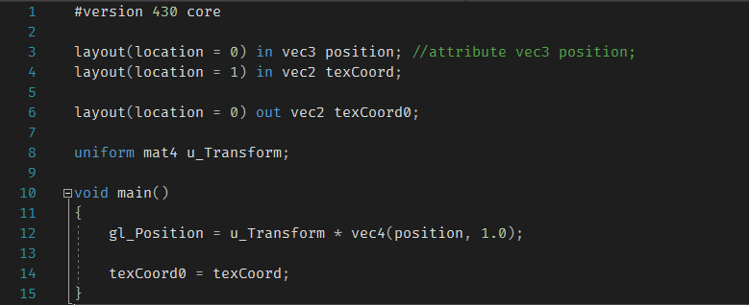
11 Regular vertex shader
This is a regular vertex shader, it takes the object’s transform as a uniform and makes sure it is positioned correctly, then it passes the texture down the pipeline.
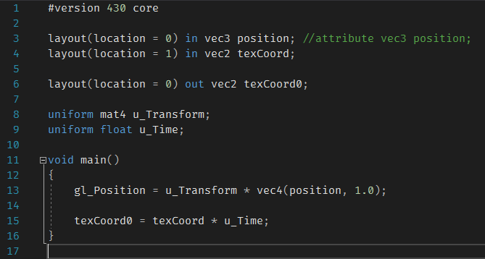
12 Texture scrolling vertex shader
This vertex shader takes an additional u_Time uniform and multiplies the texture coordinates, which are enclosed within a vector2, so that is looks as though the texture is scrolling, as it also gets smaller as time goes on. Time is a local static value found in the update() method of the Shader class.
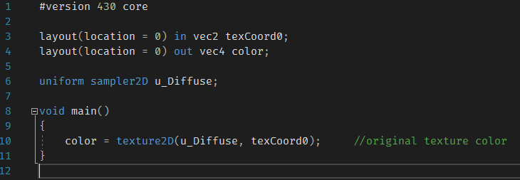
13 Regular fragment shader
The first fragment shader simply makes sure that the pixel colour is determined by the texture coordinates for the current pass. The texture2D() method is needed to turn the vector2 coordinates into a vector4 colour.

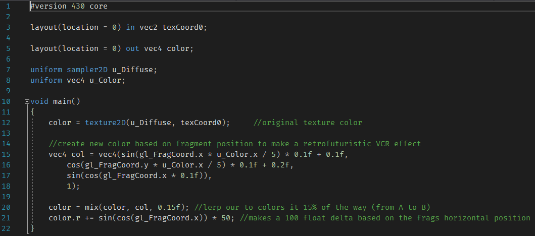
14 VCR fragment shader
Lastly, this fragment shader aims to give the object a fake, custom VCR effect.
After determining the fragment colour according to the texture, it creates a new vector4 value that is determined by the gl_FragCoord value, which is internal to the OpenGL environment.
Every component of the vector is the result of some simple mathematical operations, such as taking the sine of the product between the x-coordinate of the pixel and the colour.
The mix() function, which is already present in GLSL, is used to lerp between the original colour and the new colour, and the lerp strength can be hardcoded or read from a uniform.
Lastly, it alters the red value by a range that goes from -50 to 50, based on the x-axis position of the pixel. This gives the model a striped view that is fixed in place, making it look like a graphic artefact.

VIII – GameObject
As already stated, the Game Object class is an aggregate of many of the classes that were just introduced. The idea was to implement a centralised system that enables the developer to perform many operations jut by accessing one instanced class.
It draws its inspiration from the Unity Game Object, however it does not make use of any proper Entity Component System.
The member fields look as following.
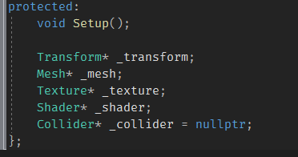
15 Game Object protected members, this allows for inheritance

Every object is a pointer to an instance. Keep in mind that the Collider member is kept at its base class so that it can later be treated as either a Sphere or a Box.
Moving on to the member methods, the first one we will go through is called initialise(); when the constructor is called, we use a member initialiser list to create pointers for the private members, using the new keyword.
Immediately after that, initialise() takes place.
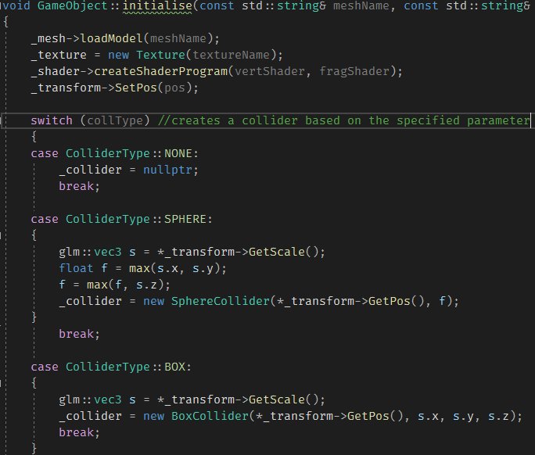
16 Initialise() method overview

On top of these, every we include every relevant getter and setter function to make it easy to manipulate its components.
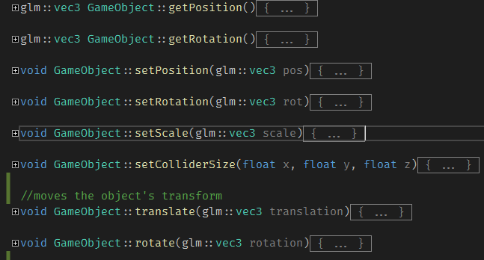
17 Getter/Setter methods
Lastly, it implements a draw() procedure, which takes the rendering Camera as a parameter, then calls the Shader and Texture binding functions, and finally issues a mesh draw call.
VIII.a – PhysicsGameObject
Some game objects implement a degree of physics in them, making greater use of both the Collider classes and a more developed version of the physics that were presented in the Player class. Clearly, the class inherits from GameObject, so, assuming each of those methods is still in use, we move onto the new features.
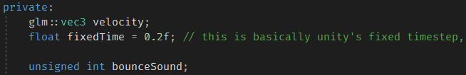
18 PhysicsGameObject private members
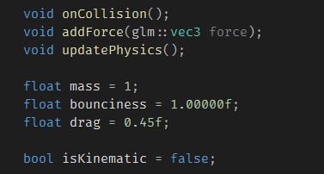
19 PhysicsGameObject public members
Velocity and fixedTime are used exactly in the same way Player does, while the sound clip is contextual to what the objects to in the game.
An onCollision() method enables the object to change vertical speed according to its bounciness value whenever a collision (calculated externally) is flagged, and its physics are related to a public member mass float value.
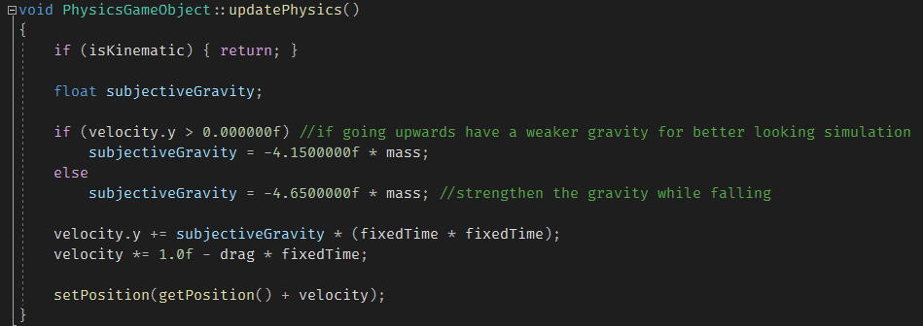
20 updatePhysics() public method
The physicsUpdate() method is called once every frame inside the physics loop. Note that the method holds a local subjectiveGravity value that changes in relation to whether the vertical velocity is either more or less than 0, like Player does.
A drag value is used to simulate air friction, diminishing the currently active forces on the object. Although in real life drag is implemented with a very specific formula, I decided to mimic the way Unity calculates it, after searching for such procedure on the web.
isKinematic is a boolean value that becomes true after the object hits the ground with very low speed. This makes sure that external physics are not calculated for such objects – hence the guard clause at the beginning of the method.
Lastly, it is worth it to illustrate the initialiseRandom() method found within the class, which uses the C-function rand() to select a random mesh, texture and shaders, then instantiates the objects with the selected values.

IX – Game
Many principles that were in use in the original version of the Class game were kept, although, as already stated, most functionalities – as far as handling objects is concerned – were abstracted into more manageable entities like Player and GameObject.
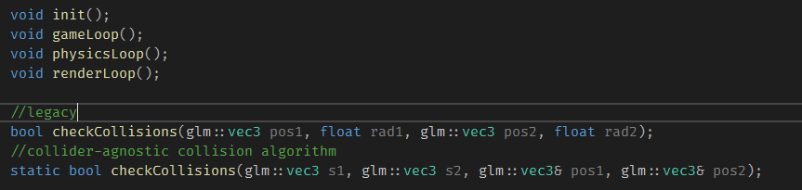
21 Game members
gameLoop() is a sequencer methods that internally calls the input, physics and rendering loops, in this order.
inputLoop() is used to check what keys were pressed, then acts accordingly. This procedure was initially taken from last year’s Games Programming I course, however, that system had many shortcomings, notably it made movement extremely blocky as every new input change created a micro-freeze.
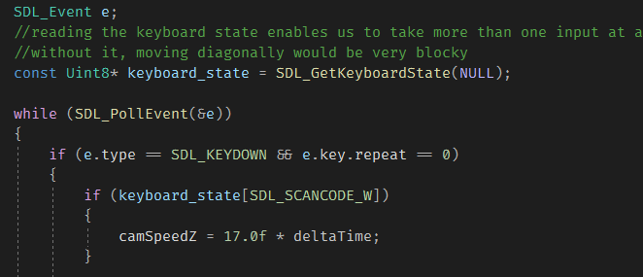
22 Small snippet of inputLoop
After some investigation, the system was changed from just polling for keypress events to also reading the keyboard state, which is an SDL proprietary function. This allows multiple keypresses to happen seamlessly.
Then, the player’s speed is stored in a separate variable so that it does not depend on keyboard presses.
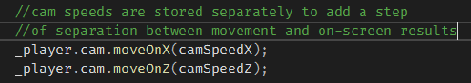
23 internal speed storing

The physics loop is where collisions take place, it checks every object inside the physics-enabled object list is checked.
The collision system has been reworked to not only calculate position and sphere radius to determine whether a collision is taking place. Instead, it uses a technique called Axis-Aligned Bounding Box (AABB) and works as follows.
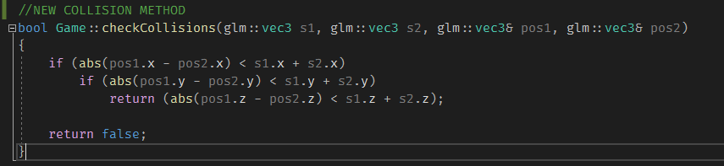
24 Collision checking
When all three axes are found to have an intersection point, the method returns true.
Lastly, to make sure that collision between different class types is possible, I implemented a dynamic-casting system that retrieves the Collider member pointer of every object, and uses dynamic_cast to find its derived type. Then, it uses that type to retrieve its size values. This make it possible to compare a Sphere with a Box, or potentially any other shape.
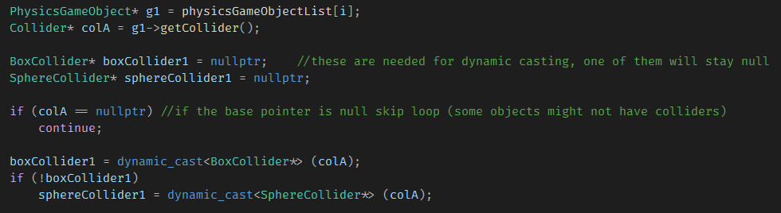
Physics loop, dynamic casting snippet
If an object is found to have fallen out of the map, it is removed from its list and the delete keyword is used on it to free the heap memory.

